USAspending Website

<https://www.usaspending.gov/#>

The website can check government spending and how it is distributed.

1. Its award data archive has raw data.

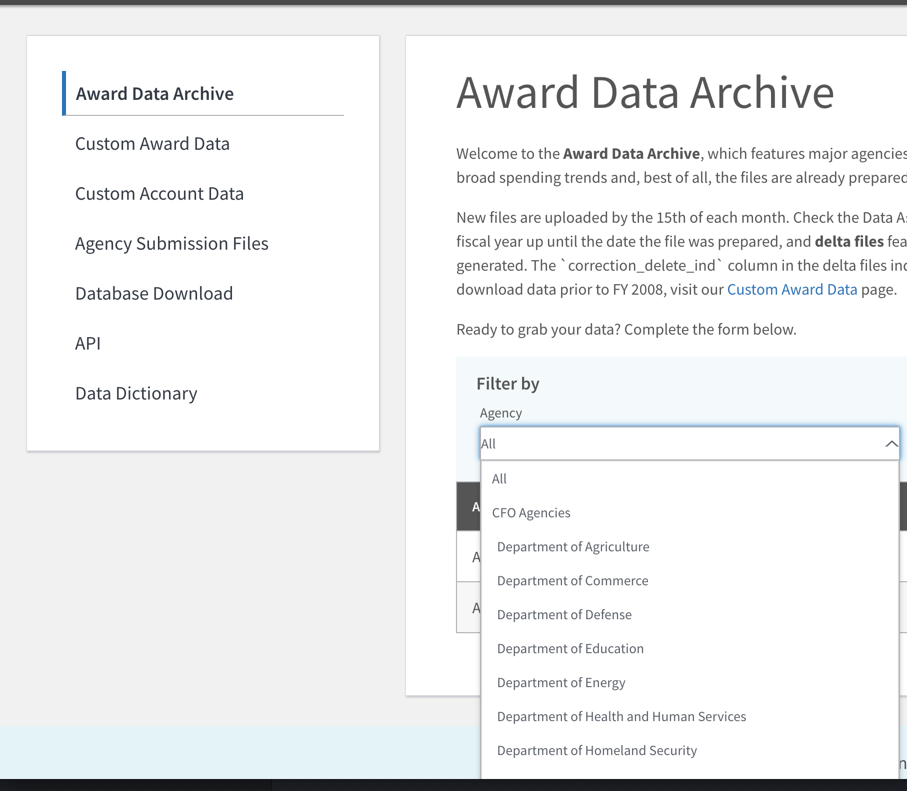

Directory : Download Center(Right Corner) → Award Data Archive

1. Keyword Search

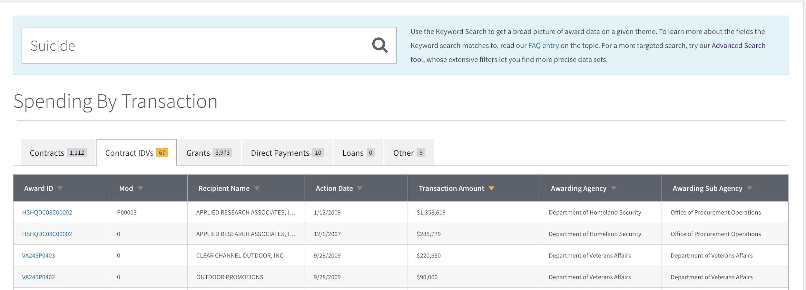

Keyword search is good for simple lookup search, but it does not have options for multiple keywords or specific agency.

1. Advanced Search

Advanced Search can allow us to search for detailed versions of data, so it is highly recommendable with data visualization.

Advanced Search can be found in Award Search (Right top corner) and select Advanced Search. For example, I inputed ‘firearm AND suicide’ and click ‘Submit Search’, it shows one research related into there.

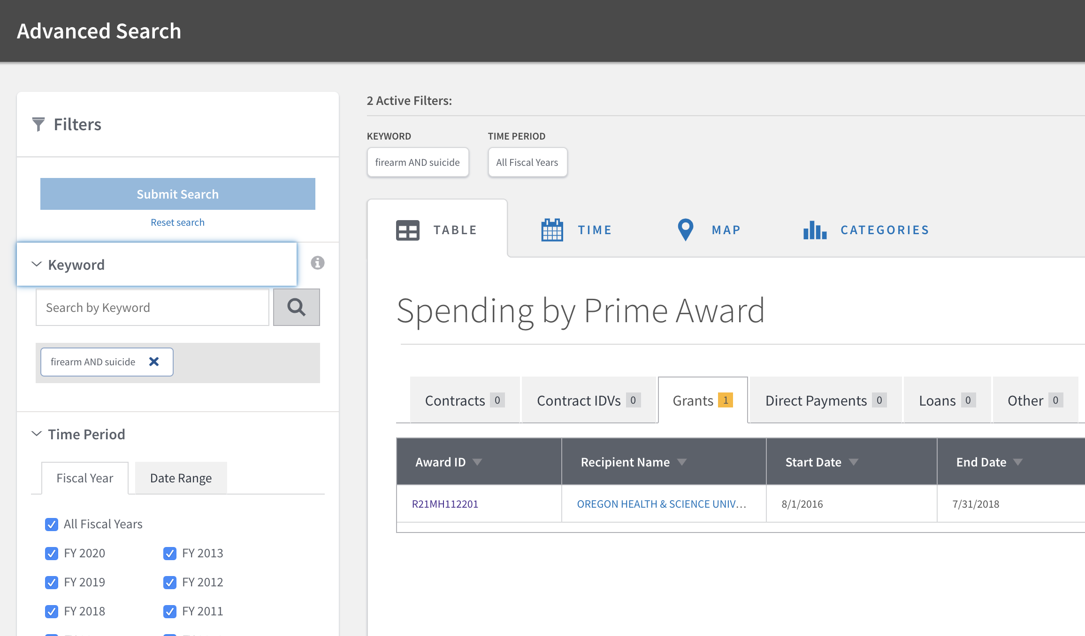

Note: Keyword looks like searching following fields and many times, it searches keywords of Award Description.

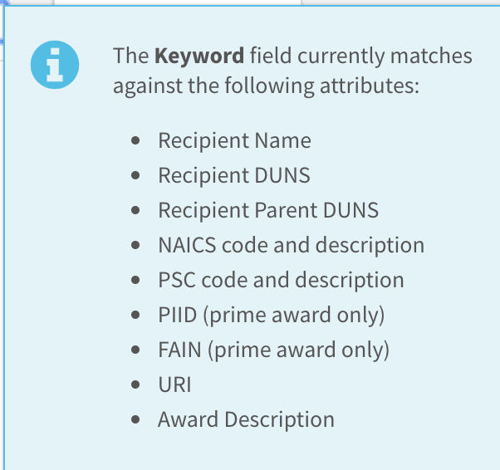

When I clicked this AwardID, it showed a summary of funding and related information.

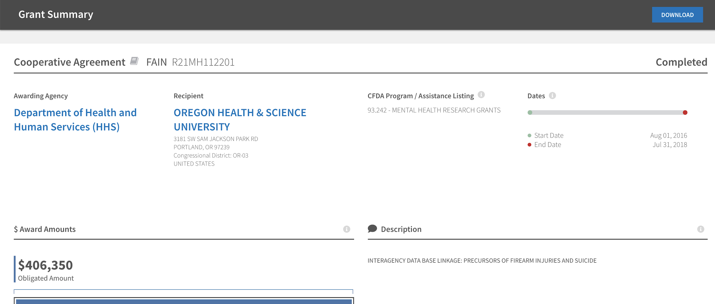

We can find out its award total amounts and description for using this fund. For example, AwardID R21MH112201 received fund based on description of INTERAGENCY DATA BASE LINKAGE: PRECURSORS OF FIREARM INJURIES AND SUICIDE and its status is ‘completed’.

For award history, we could scroll down and see its award history of all funding of this Recipient.

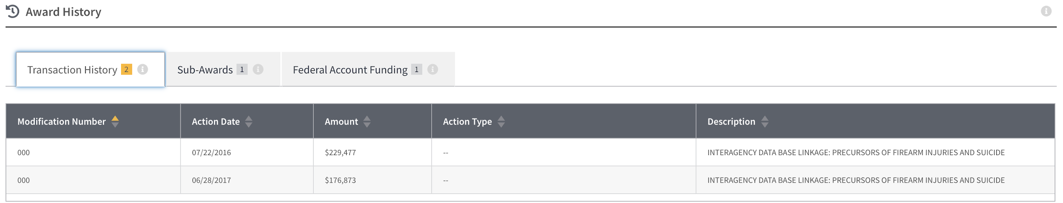

Please visit the link below for details.

<https://www.usaspending.gov/#/award/ASST_NON_R21MH112201_7529>

Note: when I searched ‘Firearm Suicide’, I believed that search engine recogized as two words, which are firearm or suicide. So, it returned all research about firearm or suicide, which are too many unrelated funding. (36,653,442 contracts) So, it should search for direct related words.

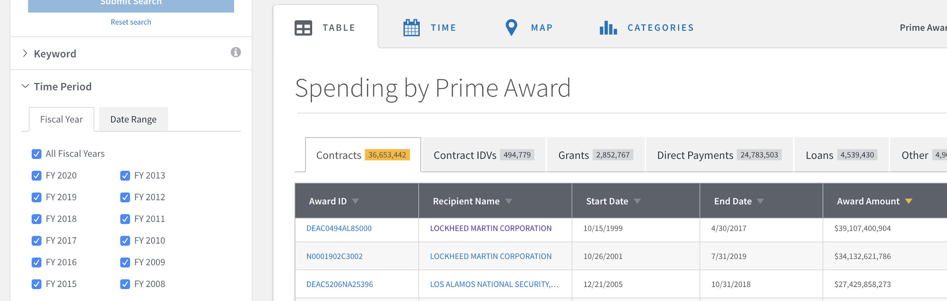

3-1. Different visualization

USAspending shows 3 other features of data visualization other than tables.

1. Time

* If you select TIME after you click ‘submit search’, it shows you government spending over time that is related to the keywords.

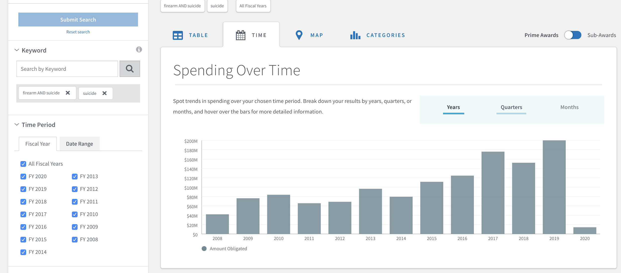

1. Map

* If you select MAP after you click ‘submit search’, it shows you spending over regions.
* One good feature that we can use is “Congressional District” Map. We can choose either obligation performance place or Recipient Location.

1. Category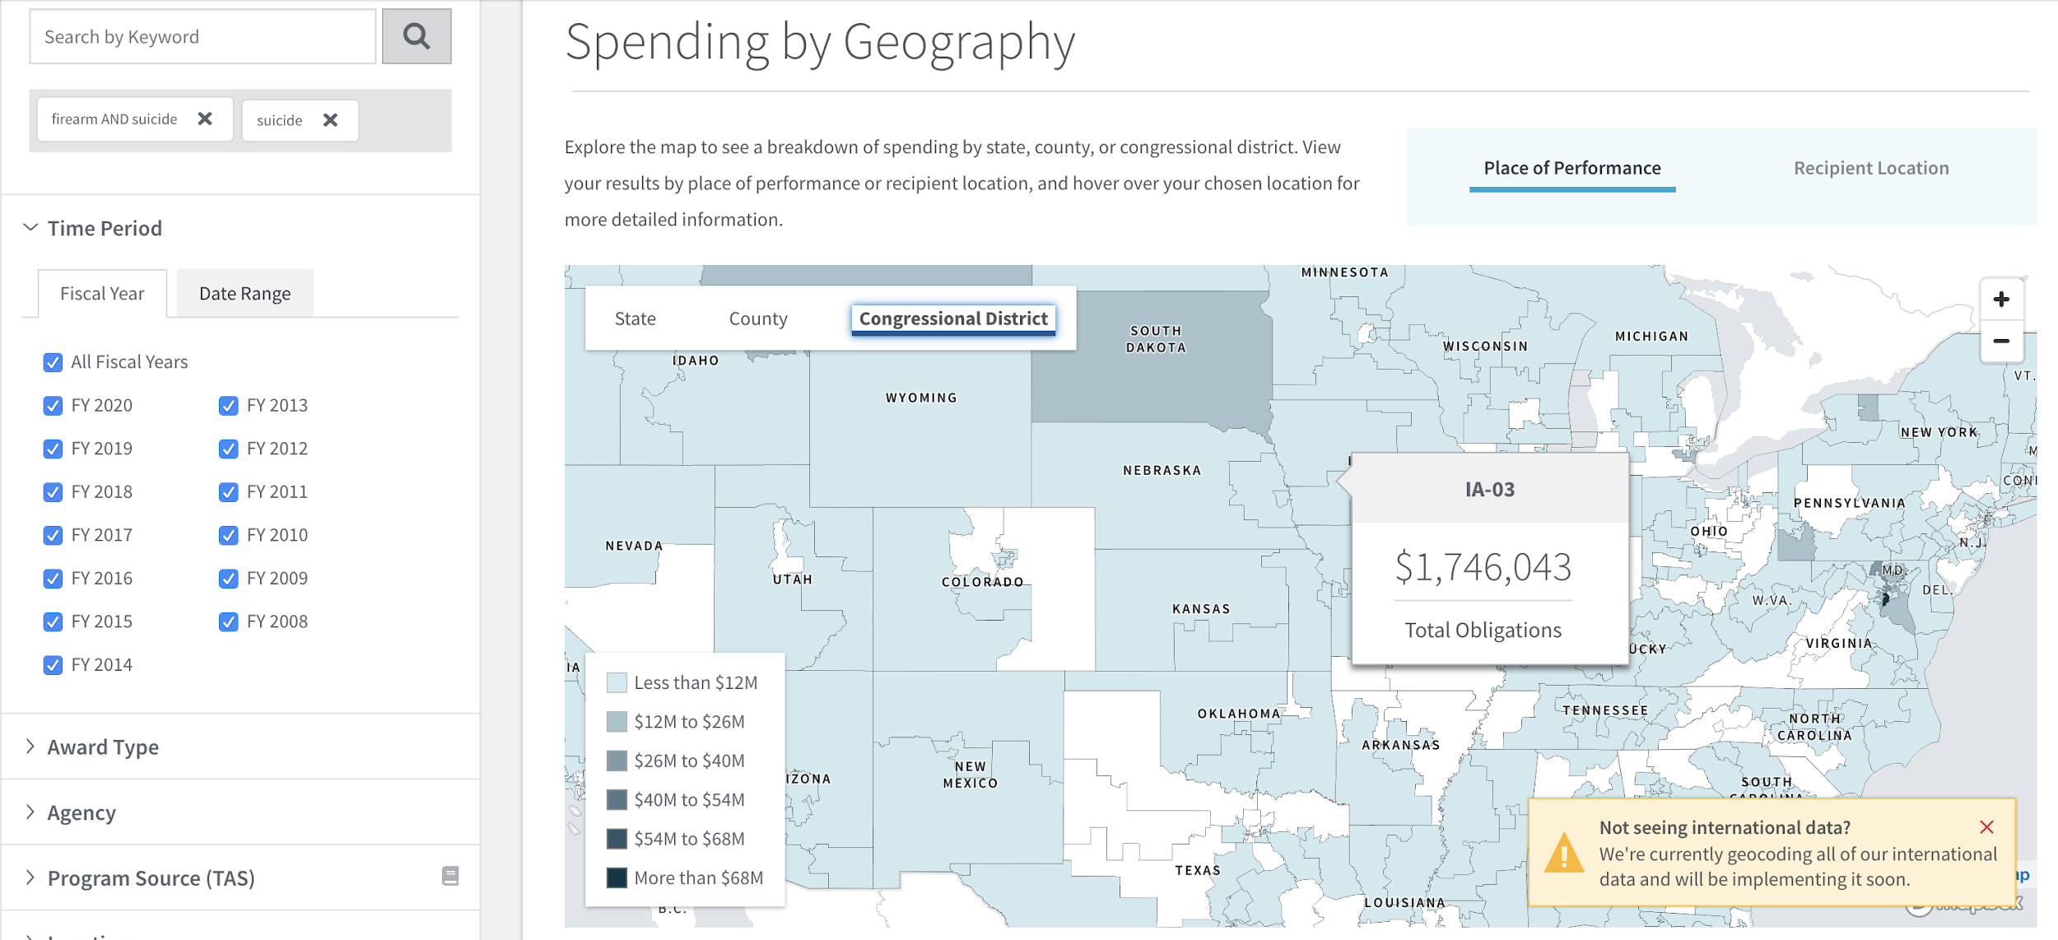

* If you select Category, it shows you 4 different options to select.
  + Awarding Agency
  + Recipient
  + CFDA Program
  + Industry Code

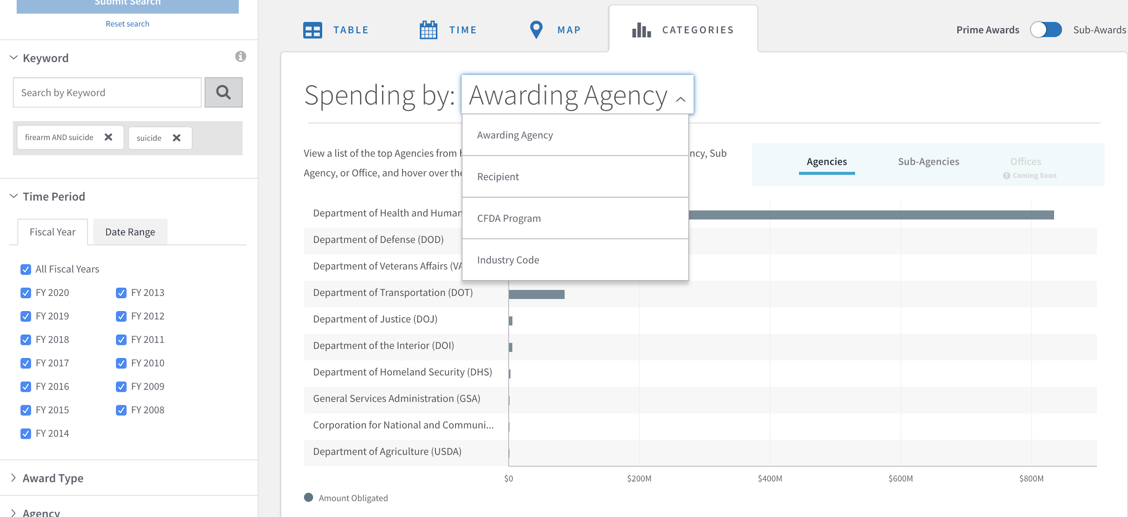

Finding : Following are top of each category.

|  |  |  |
| --- | --- | --- |
| Awarding Agency | Department of Health and Human Services | $ 834,501,285 |
| Recipient | TRANSPORTATION, CALIFORNIA DEP | $ 85,379,777 |
| CFDA Program | 93.243 - Substance Abuse and Mental Health | $ 474,732,469 |
| Industry Code | R426 - SUPPORT- PROFESSIONAL: Communication | $ 52,863,652 |

1. Raw Data

For the raw data, I was in a different project that used USAspending data. Therefore, we have sample raw data in the link below. <https://drive.google.com/drive/u/1/folders/1Rh9iNcBYNLbJE28P-SQT4JUrCoZXSzNB>

This data is a downloaded version of Point 1 with filtered for Department of Justice. Then download files for Contracts and for Financial Assistance for each available year.

Major Finding:

1. Many fundings are directly related to suicide, but not firearm related suicide. Detailed search may not work in most cases.
2. Continued from #1, government funding may not have categorized suicide funding.
3. When I filtered out just for Dep. of Health and Human Services, NY is the only state with over $ 100M funding.

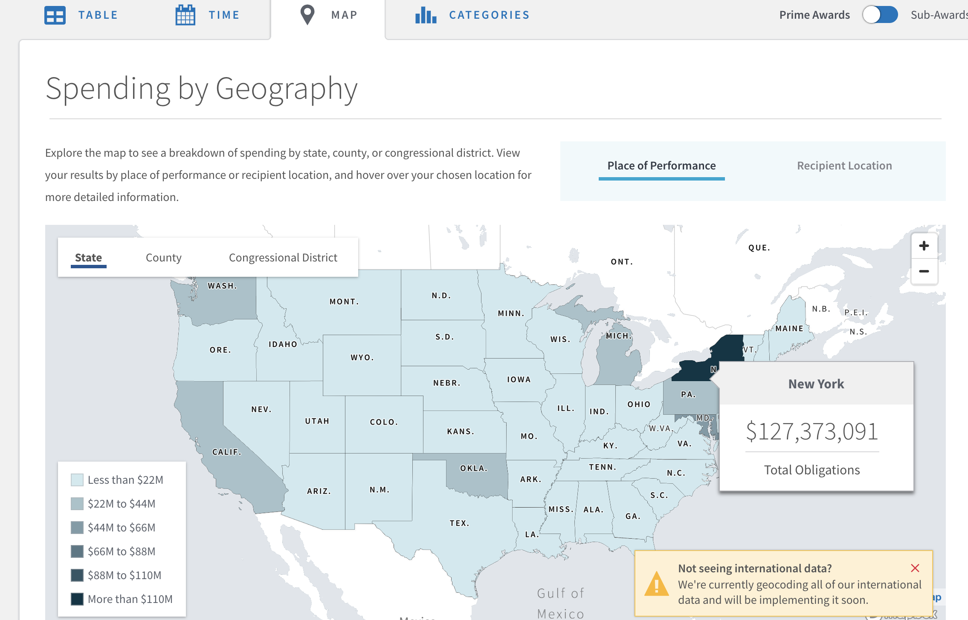

And about 25% of this funding concentrates on the NY-10 Congressional District.

